Bahria University,

Karachi Campus

## LAB EXPERIMENT NO.

3

## LIST OF TASKS

|  |  |
| --- | --- |
| **TASK NO** | **OBJECTIVE** |
| **1** | As part of a data analysis project, the team is investigating the Titanic dataset to uncover insights into passenger survival rates. One of the analysis tasks involves Implement the box plot and histogram for Titanic Data Set |
| **2** | In a workflow group create an empty workflow “ Titanic Analysis”  A) read CSV file  B) remove irrelevant columns  C) enter the name and description for all nodes  D) performed basic statistics  E) performed the column and row filter and finally write the data to output file  F) save and execute workflow. |
| **3** | Using KNIME, the team will analyze the Titanic dataset to identify the total number of male passengers who survived the disaster. This analysis will provide valuable insights into the survival patterns among male passengers aboard the Titanic, contributing to a better understanding of the factors influencing survival rates during the tragic event. |
| **4** | Calculate the total number of medals and appearances by male athletes in swimming disciplines in the Olympic Games between 1920 and 2020 by athlete and overall. |

Submitted On:

25 feb 2024

(Date: DD/MM/YY)

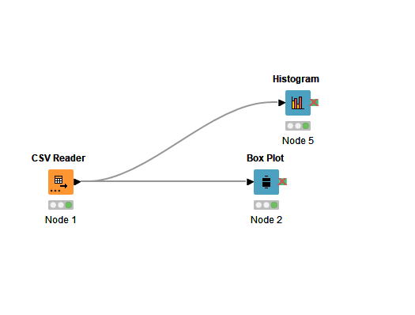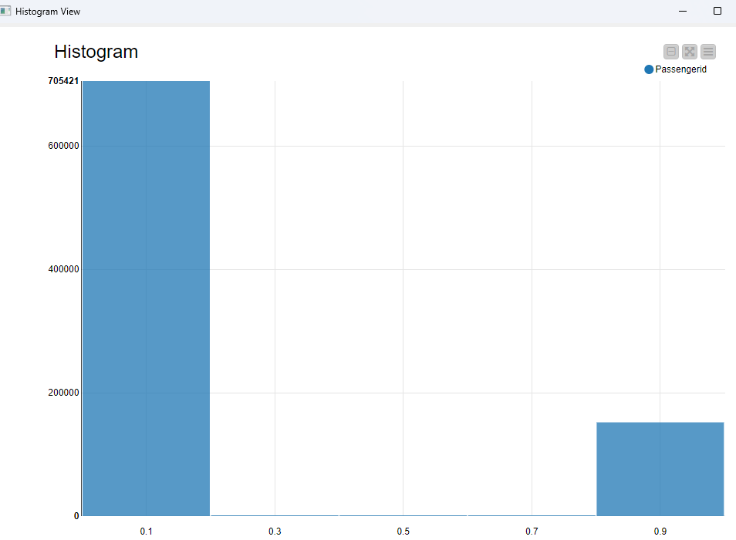

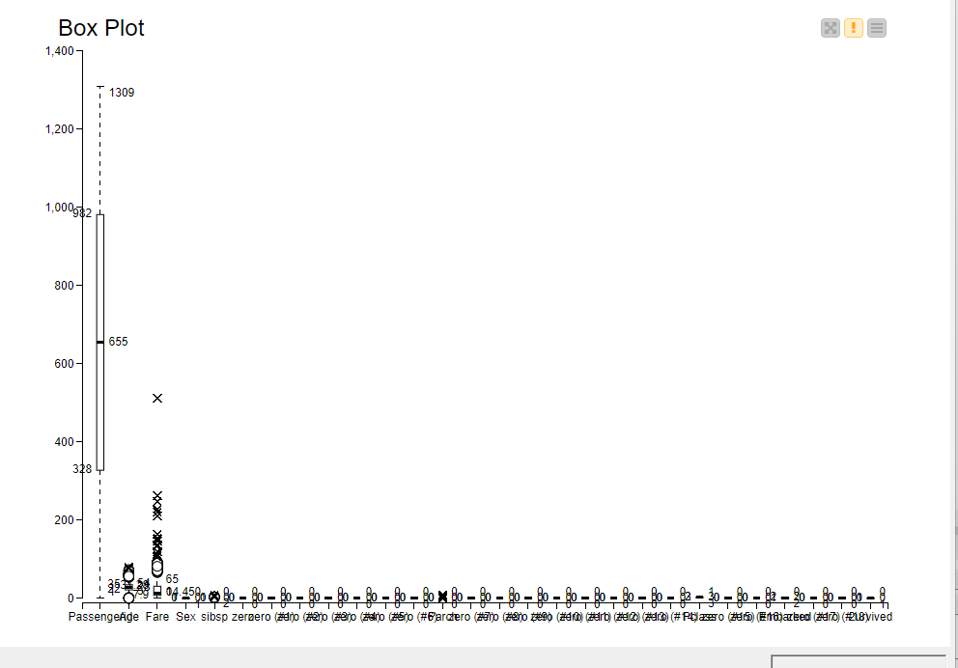

Task 2 remove irrelevant column

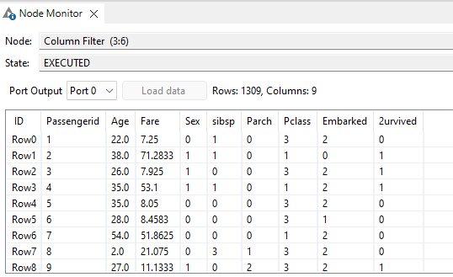

Basic stats

